Physics 3A/3B

Particle Waves and Quanta

Test 2

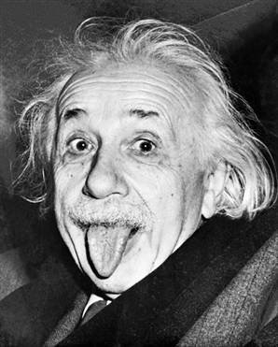

Time allowed: max 50 min
Answer all questions on the paper provided
To achieve full marks, clear, logical
working and diagrams MUST be shown.
Answers should be evaluated with an
appropriate number of significant figures.

Section A: 4 questions worth 14 marks

1. Two identical atomic clocks of extreme accuracy are set to within the same nanosecond at Greenwich in England. One of the clocks is then flown to Perth at 800 km h⁻¹. In Perth the clock is now several nanoseconds different to its “twin” still at Greenwich.

- Is the clock in Perth ahead or behind its “twin”?
Behind ( 1 mark )
(b) What has caused this difference in time?
According to Einstein’s theory of special relativity, time passage slows for a moving object. ( 1 mark )
(2 marks )

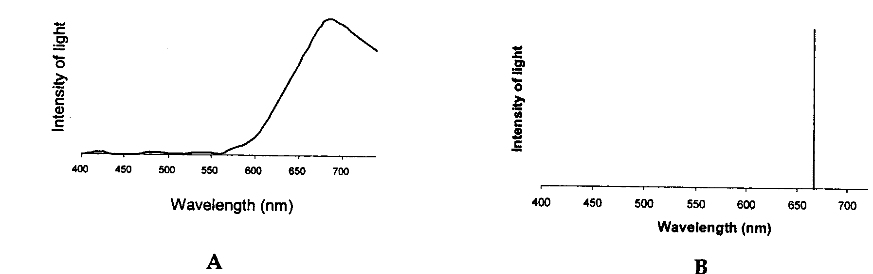
2. Consider the two spectra A and B below. One of them is the spectrum of red laser light and the other of torchlight after it has passed through transparent red plastic. Indicate which spectrum is associated with which light source, and give a reason for each one? (4 marks )

A red plastic- range of wavelengths which have been transmitted
(2 marks )
B – laser- monochromatic ( 2 marks )

3. Strong nuclear forces hold protons and neutrons together. Protons and neutrons are hadrons and each hadron is made up of three quarks. There are six types of quarks each of which has a fractional charge. Up-type quarks have a charge of +2/3 electric charge, while down-type quarks have -1/3 electric charge. If an electric charge is the charge on an electron, determine the quarks that make up a neutron and a proton. You must show your working to justify your answer.

- a neutron
neutrons are neutral so (+2/3) + (-1/3) + (-1/3) = 0
so an up + down + down ( 2 marks )

- a proton
protons have a charge of +1 so (+2/3) + (+2/3) + (-1/3) = +1
so an up + up + down ( 2 marks )
(4 marks )
4. Some minerals will show colours under ultra-violet light. What is the name of this phenomenon and how does it occur? Include a diagram with your answer.
(4 marks)
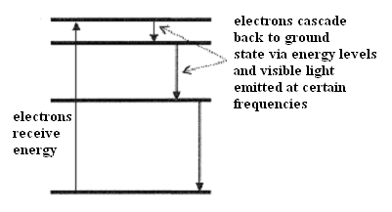
Fluorescence. (1 mark)
The mineral absorbs UV frequencies; exiting electrons at least two levels (1 mark)
Electrons then cascades back to ground state via different levels emitting lower energy and longer wavelength. Certain of these wavelengths have frequencies of visible light so colour is seen in the rock. (1 mark) Diagram ( 1 mark )

Section B: 5 questions worth 33 marks

1. The following diagram shows a type of X-ray tube.
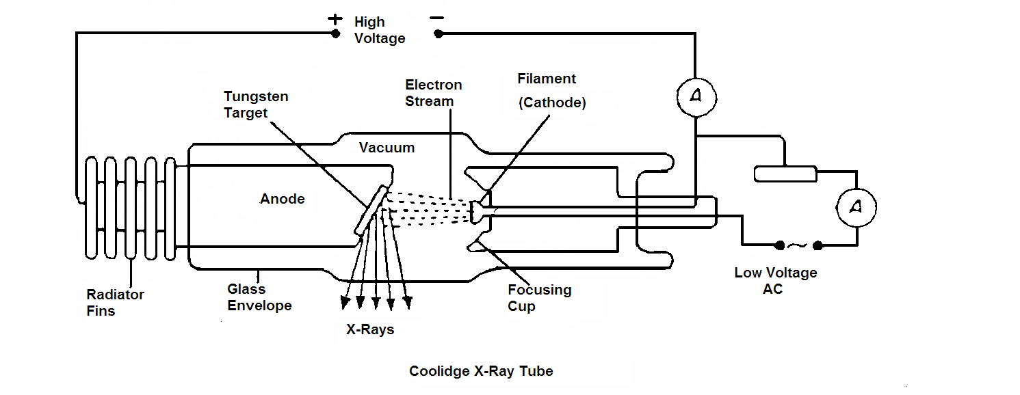
It can be used to produce hard X-Rays or less penetrating soft X-Rays.
a) What adjustments can be made to this X-ray tube to change the wavelength of the X-Rays produced. Explain.

Adjust the High Voltage, anode /cathode potential ∞ to energy
(2 marks)
b) Several of the X-ray photons produced will be characteristic of the tungsten target. Explain how these are related to tungsten atoms?
Electron transitions caused by bombarding electrons knocking out inner electrons results in a line emission spectra in the xray band which is characteristic of tungsten
(2 marks )

c) If the high voltage is set at 55 kV, what is the maximum frequency of the X-Rays produced?
(4 marks )
W = Vq
= 55 x 10³ x 1.6 x 10⁻¹⁹
= 8.8 x 10⁻¹⁵ J (2 marks)

E = hf
8.8 x 10⁻¹⁵ = 6.63 x 10⁻³⁴ x f
f = 1.33 x 10¹⁹ Hz ( 2 marks )

2.
The energy levels of atomic sodium are shown below:

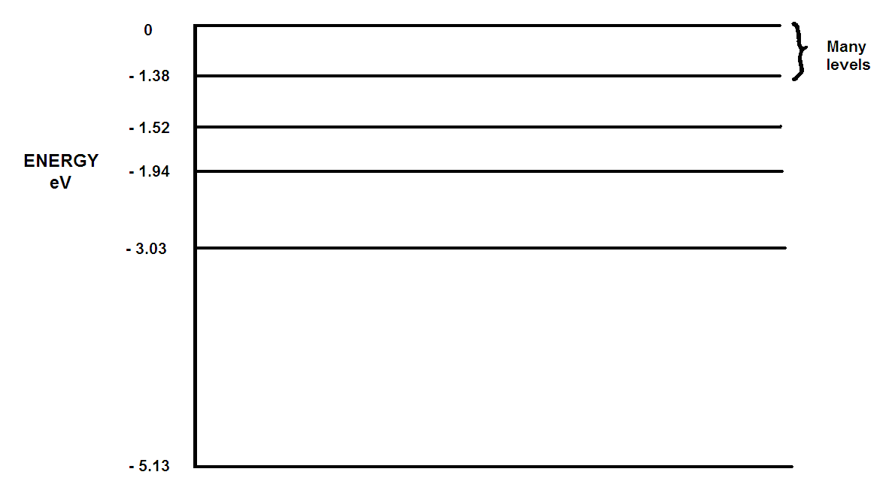

a) Sodium atoms are bombarded with electrons of energy 3.50 eV. What will be the possible energy (or energies) of the photons emitted?
(3 marks)
E = E₃ – E₁ E = E₃ – E₂
= -1.94 - -5.13 = -1.94 - -3.03
= 3.19 eV ( 1 mark ) = 1.09 eV (1 mark )

E = E₂ – E₁
= -3.03- –5.13
= 2.1 eV ( 1 mark )

b) What is the shortest wavelength of radiation that sodium vapour could emit? (Note: answer for any incoming value of energy )
(3 marks)

E = E∞ - E₁
= 0 - - 5.13
= 5.13 eV

E = 5.13 x 1.6 x 10⁻¹⁹
= 8.208 x 10⁻¹⁹ J (1 mark )

E = hf
f = 8.208 x 10⁻¹⁹/6.63 x 10⁻³⁴
= 1.238 x 10¹⁵ Hz ( 1 mark )

C = f x λ
λ = 3 x 10⁸ / 1.238 x 10¹⁵
= 2.42 x 10⁻⁷ m ( 1mark)

c) Which transition accounts for the characteristic flame colour of sodium which has a wavelength of 5.89 x 10⁻⁷m?
(4 marks)

C = f x λ
f = 3 x 10⁸ / 5.89 x 10⁻⁷
= 5.09 x 10¹⁴ Hz (1 mark)

E = h x f
= 6.63 x 10⁻³⁴ x 5.09 x 10¹⁴
= 3.375 x 10⁻¹⁹ J ( 1 mark)
= 3.377 x 10⁻¹⁹ / 1.6 x 10⁻¹⁹
= 2.11 eV ( 1 mark )

E2 to E1 ( 1 mark )

3.a. Consider the following statement.
“The distances to different galaxies is proportional to red-shift of that galaxy with the more the red-shift, the further away the galaxy.”
This relationship is best know as _Hubbles law____ ? (1 mark)
b. How does “red-shift” support the Big Bang Theory?
(3 marks)
Redshift of light which is caused by the Doppler effect. (1 mark)

When an object is moving away from the observer, the wavelengths are increased. In light, this causes a shift towards the red end of the spectrum – hence red-shift.
(1 mark)
The red-shift of galaxies we observe show they are moving away from us which is evidence of a large explosion from a single point – the Big Bang Theory.
(1 mark)
c. The Big Bang theory predicts that the universe is expanding.
Name and describe two possible futures for our expanding universe.
(3 marks)
Open universe ( ½ Mark ) – in which the universe will keep expanding forever. (1 mark)

Closed universe ( ½ Mark ) – where the universe has a finite size and will stop expanding (1 mark)

4. Consider the following example which helps to explain Einstein’s special relativity. John is standing in the middle of a train which is
travelling very fast. John turns on a light at the instant the middle of the train passes Scott, who is standing on a platform.
The diagram below shows this situation. Your answers are with reference to the light striking the end walls of the train

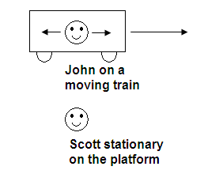
  - What does John see happen?
John will see the light hit the walls at the same time. (1 mark)
b. What does Scott see happen?
Scott will see the light hit the back wall first then the front wall. (1mark)
c. Who is right, John or Scott? Explain your answer. Both are right. (1 mark)
One set of simultaneous events are not necessary simultaneous for another observer moving at different speed. (1 mark)
(2 marks)
5. The following graph shows the factor by which mass increases with increasing velocity approaching the speed of light.

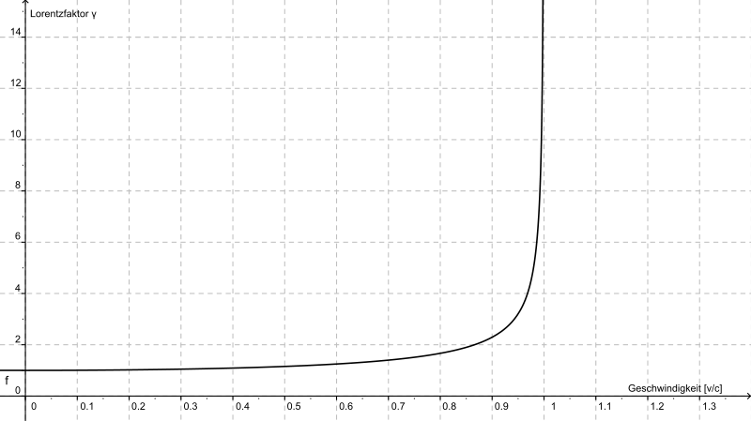
Mass increase
v/c

A proton of mass 1.67 x 10⁻²⁷ kg is accelerated in the Large Hadron Collider until it reaches 0.95c
(c = speed of light).

(a) Estimate the new mass (in kg ) of the proton from the graph. (2 marks)
From graph mass increases roughly by 3X
(1 mark)
1.67 x 10⁻²⁷ x 3 = 5.01 x 10⁻²⁷ kg
(1 mark)

- What is the reason for this apparent increase in mass? (1 mark)
Some of energy being put into proton to accelerate causes a mass increase E = mc².

Einstein derived the mathematical equation showing how mass changes with speed.
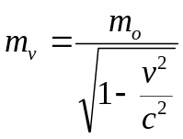
where m₀ is the rest mass and m_{v} is the mass when moving (in kg).

Using the equation above, the calculated mass of the proton when it is moving at 0.99c is or about a 7X increase.

- Assuming that a proton is accelerated by the LHC to 0.99c, calculate the new mass of the proton when travelling at this speed.

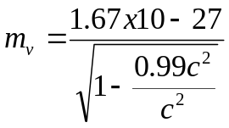

Mv = 1.18 x 10-²⁶ kg

(2 marks)
(c) Why is it impossible for the proton to travel at or faster than the speed of
light? (2 marks)
The proton cannot be accelerated to the speed of light its mass approaches infinity, this would require and infinitely large force to accelerate the proton.
End of Test

